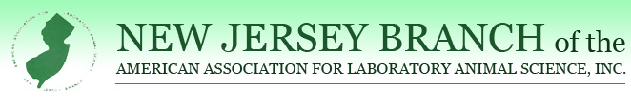THE BIO-SERV
ENHANCEMENT OR IMPROVEMENT OF ANIMAL WELFARE AWARD
This award is sponsored by Bio-Serv and is presented annually to a person who has exhibited a positive impact to enrich, enhance, and or improve the lives of animals or the environment they work in regard to animal welfare.
The award consists of a plaque and $250. The deadline for nominations is Friday August 26, 2022.
CRITERIA:
- Has enriched the lives of the animals they work with.
- Has enhanced the living environment for the animal colonies they work with.
- Has positively impacted research and the morale of the animal care staff with improvements.
- Has displayed the 3 R’s (Reduction, Refinement, Replacement) in their plan for Enhancement and Improvement.
- Has reduced or eliminated distress or created other benefits for the animals they work with.
- Must be a member in good standing of the New Jersey Branch of AALAS.
- A person from within the New Jersey Branch of AALAS must nominate the candidate.
- Anyone having received this award cannot be nominated for the same award in consecutive years.

I would like to nominate_____________________________for the Bio-Serv Enhancement or Improvement of Animal Welfare Award.
CANDIDATE CONTACT EMAIL/PHONE:_______________________________________
Please briefly outline why this candidate should be considered for this award: ________________________________________________________________________________________________________________________________________________________________________
________________________________________________________________________________________________________________________________________________________________________________________________________________________________________________________________________________________________________________________________________________
____________________________________________________________________________________

SIGNATURE OF PERSON NOMINATING THIS WORTHY INDIVIDUAL:________________________
PRINT SIGNATURE:_______________________________________
PHONE/EMAIL:__________________________________________

Please either email or mail this nomination to:
Colin Sabine
220 Evans Way, Suite 1
Somerville, NJ 08876
colin@wffisher.com

