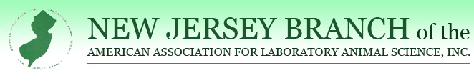Allentown, Inc. Manager of the Year Award
This award is sponsored by Allentown, Inc. and presented annually to a Facility Manager or Supervisor in recognition of their efforts and achievements in the field of Laboratory Animal Management.
CRITERIA:
- Be a facility supervisor or manager (not a department manager or supervisor).
- Be a member in good standing of the New Jersey Branch of AALAS.
- Should actively participate with lab animal technicians and/or branch affairs.
- AALAS certification preferred, but not mandatory.
- A person from within the New Jersey Branch of AALAS must nominate the candidate.
- Anyone having received this award cannot be nominated for the same award in consecutive years.
The award consists of a plaque of recognition and a $250.00 check. The deadline for nominations is Friday August 26, 2022.
I would like to nominate___________________________________for the Allentown, Inc. Manager of the Year Award.
CANDIDATE CONTACT EMAIL/PHONE:_______________________________________________
Please briefly outline why this individual should be considered for this award: ________________________________________________________________________________________________________________________________________________________________________
________________________________________________________________________________________________________________________________________________________________________________________________________________________________________________________________________________________________________________________________________________
____________________________________________________________________________________
SIGNATURE OF PERSON NOMINATING THIS WORTHY INDIVIDUAL:________________________
PRINT SIGNATURE:_______________________________________
PHONE/EMAIL:__________________________________________
Please either email or mail this nomination to:
Colin Sabine
220 Evans Way, Suite 1
Somerville, NJ 08876
colin@wffisher.com

