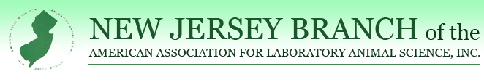New Jersey Branch of AALAS
Outstanding Contribution Award
This award is presented annually to an individual who has contributed significantly to the field of Laboratory Animal Medicine and Welfare. The nominee does not necessarily need to be a New Jersey Branch of AALAS member.
Please Note: Anyone having received this award cannot be nominated for the same award in consecutive years.
The award consists of a plaque of recognition.
The deadline for nominations is Friday, August 16, 2024.
I would like to nominate___________________________________for the New Jersey Branch of AALAS Outstanding Contribution Award.
NAME OF CANDIDATE: _______________________________________________________
CANDIDATE CONTACT EMAIL/PHONE: _______________________________________
Please briefly outline why this individual should be considered for this award: ____________________________________________________________________________________________________________________________________________________________________________________________________________________________________________________________________________________________________________________________________________________________________________________________________________________________________
____________________________________________________________________________________
________________________________________________________________________________________________________________________________________________________________________

SIGNATURE OF PERSON NOMINATING THIS WORTHY INDIVIDUAL: _________________________________________________________
PRINT SIGNATURE:_______________________________________
PHONE/EMAIL:__________________________________________
Please either email or mail this nomination to:
Colin Sabine
220 Evans Way, Suite 4
Somerville, NJ 08876
colin@wffisher.com

